**Name: ……………………………………….………… Date: ………………….….**

**MATHEMATICS**

**1. How many sides do they have?**

_______ sides ______ sides

**2. Underline the greater number.**

6 or 16 40 or 04

**3. Multiply:**

4 1 0

**x** 1 **x** 2

________ __________

**4. Count and write the number word.**

______________

______________

______________

**5. Fill in tens and ones.**

_________ tens ________ ones =

_______ tens ______ one = ________

**General knowledge**

What is the name of your Mathematics teacher?

...................................................................................................................................

**ENGLISH**

**Match words to their plurals.**

**One more than one**

car boats

lorry trains

donkey cars

bus donkeys

train lorries

boat buses

**2. Match words to their correct forms.**

oatb donkey

melca road

terwa boat

usb camel

oard water

keydon bus

**General knowledge**

How many days make up a year?

...............................................................................................................................

**LITERACY ONE**

1. Write the words correctly.

a) lamec ......................................... b) god .........................................

c) kilm ............................................. d) atgo ........................................

**2. Write words with these sounds.**

a) sl ................................................. b) wi ............................................

c) rl ................................................. d) ki .............................................

**3. Write the jumbled words correctly.**

a) food We grow eat to.

......................................................................................................................

b) from get garden We food the.

.......................................................................................................................

**General knowledge**

Mention **one** element of a good house.

................................................................................................................................

**LITERACY TWO**

1. ..................................................... is the movement of people goods and services from one place to another.

2. Mention **the four** types of transport found in our community.

i) ......................................................................................................................

ii) ......................................................................................................................

iii) ......................................................................................................................

iv) ......................................................................................................................

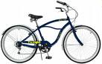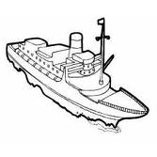3. Name these means of transport.

.............................................. ............................................

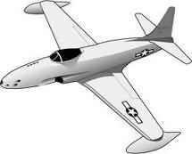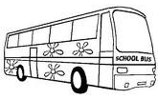

............................................. .............................................

4. What title is given to a person who flies an aeroplane.

........................................................................................................................

**General knowledge**

Give atleast**two** materials used in constructing a permanent house.

i) ..................................................................

ii) .................................................................

|  |  |  |
| --- | --- | --- |
| **Comment:** |  | |
| **Name of Parent** |  | **Sign:** |
| **Date** |  | **Contact:** |

**Name: ……………………………………….………… Date: ………………….….**

**MATHEMATICS**

**1. Read and work out:**

a) Eighth balls **plus** two balls give _________________________

b) Tom has **4** apples

James has **3** apples

John has **2** apples

i) Who has most apples?

_______________________________________________________

ii) They altogether have ______________________ apples.

**2. Form a big set.**

**3. Multiply:**

1 1

**x** 4

__________

**4.** How many **legs** do **5** stools have?

____________ legs

**5. Find the missing numbers in the boxes.**

+ 1 = 3 4 + = 6

**General knowledge**

Who is the Guild president of Kings Schools?

___________________________________________________________________

**ENGLISH**

**1. Match small to capital.**

bus PILOT

donkey TRACTOR

train BUS

aeroplane DONKEY

tractor TRAIN

pilot AEROPLANE

**2. Make sentences using the words below.**

bus

.............................................................................................................................

donkey

.............................................................................................................................**3. Write the plurals.**

bus .......................................... donkey .......................................

train .......................................... car ................................................

**General knowledge**

When did Term III 2016 begin?

...........................................................................................................................

**LITERACY ONE**

**1. Fill in the missing letter.**

a) w............ld b) le..........pard c) el........phant

**2. Make sentences using these words.**

a) monkey

.............................................................................................................................

b) bring

.............................................................................................................................

c) domestic

.............................................................................................................................

**3. Write the jumbled sentences correctly.**

a) Have birds wings feathers and.

.............................................................................................................................

b) Birds nest some in stay.

.............................................................................................................................

c) Writing still I am.

.............................................................................................................................

d) Your stand friend near.

.............................................................................................................................

**LITERACY TWO**

1. A person who flies an aeroplane is called?

.............................................................................................................................

2. How do you come to school?

.............................................................................................................................

3. Mention **any three** means of road transport.

.............................................................................................................................

4. Give the place where we can find these means.

a) taxi ..........................................................................................................

b) bus .........................................................................................................

5. A ..................................................... collects money in the bus or taxi.

6. Draw a person driving a car.

**General knowledge**

Mention **one** tool used by a carpenter in making furniture.

.........................................................................................................................

|  |  |  |
| --- | --- | --- |
| **Comment:** |  | |
| **Name of Parent** |  | **Sign:** |
| **Date** |  | **Contact:** |

**Name: ……………………………………….………… Date: ………………….….**

**MATHEMATICS**



8

**1. Show the time.**

It is 9 o’clock

2. **Find the missing numbers in the boxes.**

a) – 3 = 5 b) 9 – = 4

3. **Fill in hundreds, tens and ones.**

_____ tens _____ ones =

_____ tens ______ ones = _________

**4. Divide:**

6 $÷$ 6 = _________ 8 $÷$ 4 = _______

Share **4** balls between **2** boys.

Each boy gets _____________ balls.

**5. Compare objects using bigger, or smaller.**

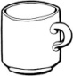 **cup basket**

Which object covers a bigger space?

____________________________________________________________________

**General knowledge**

Mention **three** local television stations in Uganda.

i) ........................................................... ii) ...............................................

iii) ..........................................................

**ENGLISH**

**1. Write correct sentences using the given words.**

a) sailing

............................................................................................................................

b) riding

............................................................................................................................

c) travelling

............................................................................................................................

d) running

............................................................................................................................

e) flying

............................................................................................................................

f) walking

............................................................................................................................

g) driving

............................................................................................................................

**2. Match people to their occupations.**

driver rides a bicycle.

pilot travels a train

captain drives cares

cylist flies aeroplanes

**General knowledge**

Name the three colour of the Uganda flag.

i) ........................................ ii) ................................ iii) ............................

**LITERACY ONE**

1. Write words with these sounds.

a) ou ............................................. b) ght ......................................

c) oo ..............................................

2. Choose the correct word from the box and fill in correctly.

**lunch, trip, lions, donkeys, snakes, wild, banana**

Last term P.1 went for a ...................................... in the wild life centre.

They saw there some ................... animals like....................., ........................ and leopards.

When some children were giving ............................. to the monkeys, others were riding ................................................. Later they were served .................................... from the garden and lastly they went to Aero beach.

**General knowledge**

Where do we find the Uganda wild life education centre?

.............................................................................................................................

**LITERACY TWO**

1. Give the commonest type of transport.

............................................................................................................................

2. Name **any four** road users.

i) .......................................................... ii) ..............................................

iii) ......................................................... iv) ............................................

3. Identify **any one** animal used for transport.

............................................................................................................................

4. Draw these means of transport.

|  |  |  |
| --- | --- | --- |
|  |  |  |
| **ambulance** | **lorry** | **camel** |

5. What is the slowest mean of transport?

............................................................................................................................

6. How many days did God/Allah take to create the world?

............................................................................................................................

**General knowledge**

Draw the following road signs.

|  |  |  |
| --- | --- | --- |
| a) humps ahead | b) round about | c) No parking |

|  |  |  |
| --- | --- | --- |
| **Comment:** |  | |
| **Name of Parent** |  | **Sign:** |
| **Date** |  | **Contact:** |

**Name: ……………………………………….………… Date: ………………….….**

**MATHEMATICS**

**1. Expand numbers.**

**T O**

6 3 = 60 + 3

**T O**

4 5 = _________ + _________

**H T O**

1 7 2 = ___________ + _________ + _________

**2. Draw these sets.**

An empty set________________ A set of **6** baskets.__________________

**3. Write numbers in words.**

2nd $\frac{1}{4}$

_________________________ ________________________

75 ___________________________

**4. How many are they?**

= __________ squares = __________ triangles

**5. Compare trees using taller orshorter.**

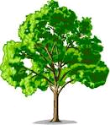 **P**

tree **p** is _________________ than tree **K**

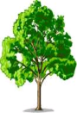 **K**

Which tree is **shorter**?

____________________________________________________________________

**General knowledge**

When do you celebrate your birthday?

____________________________________________________________________

**ENGLISH**

**1. Write the plurals.**

**one more than one**

ball ...........................................  
 pot ...........................................

basket ...........................................

rope ...........................................

mat ...........................................

doll ...........................................

**2. Use the correct prepositions to complete the sentences.**

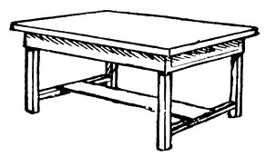

The ball is ...................................... the table.

The pencil is .................................... the tin.



The girl is standing ................................ the tree.



The cat is ..................................... the table.

**General knowledge**

When do we celebrate Christmas?

.............................................................................................................................

**LITERACY ONE**

**1. Complete the riddles correctly.**

a) I am made out of wood, you sit on me in your class. Who am I?

............................................................................................................................

b) I am a machine, I carry many people, I move on rails and am very long.

Who am I? .................................................................................................

c) I am soil, people get me from swamps. You use me to make pots.

Who am I? .................................................................................................

d) I am an animal, I guard people’s homes. My young one is a puppy.

Who am I? .................................................................................................

e) I am a place, you come to me to learn. Who am I?

............................................................................................................................

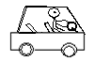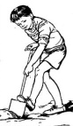**2. Make sentences with these pictures.**

a) Ignitius

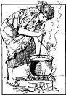 .........................................................................................

b) Mother

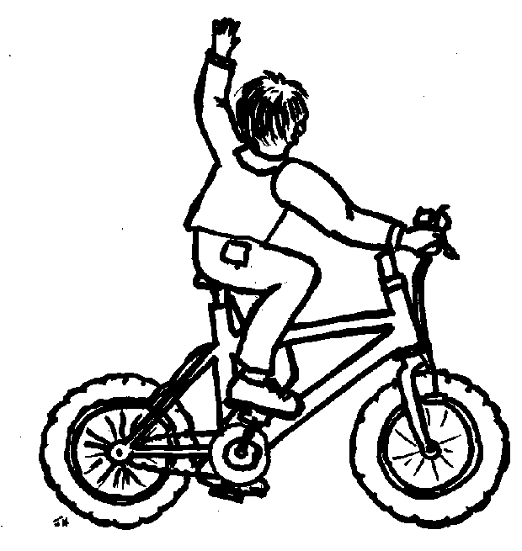 ...........................................................................................

c) Tom

........................................................................................

**General knowledge**

How do you come to school?

.............................................................................................................................

**LITERACY TWO**

1. Circle the bad people in a community.

robber, teacher, mad people, doctor, defilers, nurse, kidnappers

2. Give **any four** common accidents on the road.

i) ........................................................................................................................

ii) ........................................................................................................................

3. Name these means of modern communication.

|  |  |
| --- | --- |
|  |  |
|  |  |

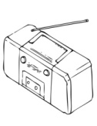

5. Draw and name things Allah created to give us light.

|  |  |  |
| --- | --- | --- |
|  |  |  |
|  |  |  |

**General knowledge**

What is the work of a police man?

............................................................................................................................

|  |  |  |
| --- | --- | --- |
| **Comment:** |  | |
| **Name of Parent** |  | **Sign:** |
| **Date** |  | **Contact:** |

**Name: ……………………………………….………… Date: ………………….….**

**MATHEMATICS**

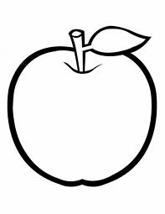**1. Study the shopping bill and answer questions.**

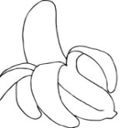

**an apple yellow banana**

**Shs. 800 Shs. 300**

**An orange Safi**

**Sh. 100 Shs. 500**

**Questions:**

a) How many items are shown on the list?

_____________________________________________________________________

b) How much money do we pay for a yellow banana?

_____________________________________________________________________

c) What is the most expensive item on the list?

_____________________________________________________________________

d) If Tom wants to buy an orange and safi, how much will he pay altogether?

____________________________________________________________________

e) What is the cheapest item on the list?

_____________________________________________________________________

**General knowledge**

There are 7 months with 31 days and 4 months with 30 days. How many months have 28 days?

____________________________________________________________________

**ENGLISH**

**1. Use the words given in the box to complete the story.**

**string, water, banana fibres, pots, palm leaves, mat, clay, basket**

These are .................................... we make them from ...............................

for drinking ................................. The ................................ are made from ................................ We also make ......................... from ........................ on.

**2. Give the plurals.**

a) pot ............................................... b) basket ................................

c) palm leaf.....................................

**LITERACY ONE**

1. Fill in the missing letters.

a) tr.........nsport b) tra..........n c) b........s d) b..........cycle e) l..........rry

2. Draw these road signs.

|  |  |  |  |
| --- | --- | --- | --- |
|  |  |  |  |
| parking | round about | No parking | School ahead |

**LITERACY TWO**

1. Name this thing found at school.

...................................................................

2. Draw these things found in the sitting room.

|  |  |  |
| --- | --- | --- |
|  |  |  |
| table | mat | chair |

3. Name these things we use to clean our home.

|  |  |  |  |  |
| --- | --- | --- | --- | --- |
| C:\Users\Secretary\Documents\OTHERS\new images\tools\Broom.png | | C:\Users\Secretary\Documents\OTHERS\new images\tools\Slasher.png |  | |
|  | |  |  | |
| **Comment:** | |  | | | | |
| **Name of Parent** | |  | | | **Sign:** | |
| **Date** | |  | | | **Contact:** | |

**Name: ……………………………………….………… Date: ………………….….**

**MATHEMATICS**

1. What number has been expanded?

a) _______________ = 1= + 3 b) ___________ = 30 + 8

c) _______________ = 100 + 7 + 5

2. Form small sets.

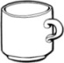











3. Fill in the missing numbers.

a) 90, 91, 92, _________, __________, 95

b) 12th, 13th, 14th, _______, _______ 17th

**General knowledge**

Form two 3 lettered English words from the members of set K for each of set P and Q. You many repeat some letters.

**Set K**

**r**

**s i**

**e y**

**ENGLISH**

**1. Add “ing to the verb.**

a) burn ............................................. b) cut ..........................................

c) splint ............................................ d) graze .......................................

e) draw ........................................... f) carry .........................................

**2. Answer correctly.**

a) What are you doing? (burning rubbish)

.............................................................................................................................

b) What are you doing? (cutting a tree)

.............................................................................................................................

c) What are you doing? (grazing cattle)

.............................................................................................................................

d) What are you doing? (splitting fire wood)

.............................................................................................................................

e) What are you doing? (drawing a picture)

.............................................................................................................................

f) What are you doing? (carrying luggage)

.............................................................................................................................

**LITERACY ONE**

1. Write words with sound “ght”

i) ............................................... ii) ...............................................

iii) .............................................

2. **Read the passage below carefully and answer questions in full sentences.**

**OUR ENVIRONMENT**

Our environment is rich because it has different materials used to make different things like banana fibres which are used to make ropes, balls, dolls etc. Other materials are clay, palm leaves, sisal and many others.

Our environment is beautiful.

**By Ashley (P.1)**

**Questions:**

a) What is the title of the passage?

.............................................................................................................................

b) What is rich according to the passage?

.............................................................................................................................

c) List **two** materials got from the environment.

i) ....................................................... ii) .....................................................

d) Who wrote the passage?

.............................................................................................................................

e) Which material is used to make dolls?

.............................................................................................................................

f) Write the last sentence of the passage.

.............................................................................................................................

**LITERACY TWO**

1. Why do people need clay?

.............................................................................................................................

2. Name **any three** things made by a carpenter.

i) ........................................................ ii) .................................................

iii) ........................................................

3. Give the sources of these things:

i) Iron sheets .........................................................................................

ii) sand .........................................................................................

iii) papyrus ........................................................................................

4. How is paper waste basket useful in our classroom?  
 .............................................................................................................................

5. Give **two** reasons why people make crafts.

i) ..........................................................................................................................

ii) .........................................................................................................................

6. Who was the father of Prophet Muhammad?

|  |  |  |
| --- | --- | --- |
| **Comment:** |  | |
| **Name of Parent** |  | **Sign:** |
| **Date** |  | **Contact:** |

.............................................................................................................................

**Name: ……………………………………….………… Date: ………………….….**

**MATHEMATICS**

**1. Add in litres.**

a) 7 litres + 3 litres = _________ b) 3 0 litres

**+** 1 5 litres

____________

**2. Tick the smaller number.**

a) 2 or 20 b) 41 or 14 c) 10 or 100

**3. Form groups of twos.**

= ________ twos

= ________ twos

**4. Read and work out.**

A cat has **2** eyes. How many eyes do **5** cats have?

_________________________________________________________________

5. Nine plus one equals ________________________

6. Eleven cups take away six cups gives ____________________________

**General knowledge**

How many heads do **8** boys have?

____________________________________________________________

**ENGLISH**

**1. Answer correctly.**

a) What do you like doing? (share)

.............................................................................................................................

b) What do you like doing? (pray)

.............................................................................................................................

c) What do you like doing? (weed)

.............................................................................................................................

**2. Complete the sentences correctly.**

a) A ........................................ keeps law and order.

b) A ........................................ treats patients.

c) A ........................................ grows crops and rears animals.

d) A ........................................ teaches children.

**( farmer, teacher, policeman, doctor)**

**General knowledge**

Write down your first name.

....................................................................................................................

**LITERACY ONE**

1. Make words with these sounds.

a) th ................................ b)ck ...................................

2. Where do we find the following means of transport?

a) buses ..........................................................................................................

b) ships and boats .......................................................................................

c) aeroplanes ........................................................................................

3. What are the two groups of living things?

i) .................................................. ii) .......................................................

**LITERACY TWO**

1. Who heads a school?

.............................................................................................................................

2. ................................................ is when people are not safe from danger.

3. Underline the causes of insecurity.

fighting, eating, poverty, stealing, quarreling, dancing

4. Mention **any three** bad acts children do at school.

i) ..........................................................................................................................

ii) .........................................................................................................................

iii) ........................................................................................................................

5. Give **any two** bad people you know in your community.

i) ...................................................... ii) .............................................

6. Name **any two people** who keep peace and security at home.

i) ........................................................ ii) ..............................................

**General knowledge**

How many eyes do six P.1 children have?

............................................................................................................................

|  |  |  |
| --- | --- | --- |
| **Comment:** |  | |
| **Name of Parent** |  | **Sign:** |
| **Date** |  | **Contact:** |

**Name: ……………………………………….………… Date: ………………….….**

**MATHEMATICS**

1. Paul weighs 6 kg

Peace weighs 4 kg

a) Who is heavier?

____________________________________________________________________

b) Who weighs 4kg?

_____________________________________________________________________

c) Find their total weight.

_____________________________________________________________________

2. Show **12** o’clock on the clock face below.



8

3. Find the missing numbers.

a)

+ 3 = 5

b) 6 + = 10

c) plus three equals four.

**ENGLISH**

**1. Match words to their plurals.**

man army men

policeman men

headmaster policemen

mother boys

boy headmasters

army man mothers

**2. Match abbreviations to full forms.**

Tr. Honourable

Dr. Headmaster

Pr. Teacher

Mr. Pastor

H/M Doctor

Hon. Minster

**LITERACY ONE**

**1. Re – arrange the words to form meaningful sentences.**

a) law and order keeps A police man.

.............................................................................................................................

b) takes care of Mother children.

.............................................................................................................................

c) help the parents friends their.

.............................................................................................................................

d) carrying a baby Mother is.

.............................................................................................................................

**2. Fill in the guided composition using the given words.**

**food, land, houses, environment, animals, lakes**

............................................. are the things around us. Plants give us ................................, medicine, firewood and shade. From ...................... we get fish and water. People live in .................................. to protect themselves against wild ...................................... People grow crops and graze animals on ...............................

**LITERACY TWO**

1. What is **a nuclear family**?

.............................................................................................................................

.............................................................................................................................

2. **Tick types of families.**

an extended, relatives, nuclear

3. Mention **any four** domestic animals.

i) ........................................................... ii) ...............................................

iii) ......................................................... iv) ..............................................

4. Name **any two** things in a home.

i) .......................................................... ii) ...............................................

5. Underline these activities done in the community.

fishing, abusing, building, jeering, farming, teaching

6. Outline **any two** people found in the church.

i) ........................................................ ii) ..............................................

|  |  |  |
| --- | --- | --- |
| **Comment:** |  | |
| **Name of Parent** |  | **Sign:** |
| **Date** |  | **Contact:** |

**Name: ……………………………………….………… Date: ………………….….**

**LITERACY ONE**

1. Fill in the missing letters.

a) or............nges b) ma.........goes

c) sug.........rca....... d) paw.........aw

2. Name **any two** plants that we eat their roots.

i) ....................................................... ii) ..............................................

3. Name the parts of a plant below.

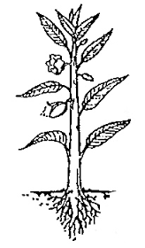

.......................... d

........................... e a ...............................

b ....................................

**c**

**LITERACY TWO**

1. ................................................ houses are houses which are strong.

2. Name these parts of a house.

**b** ...............................................

**a** ..............................................

**c** ..............................................

**e** ..............................................

**d** ..................................... **f** ......................................................

3. Why do people need houses?

.............................................................................................................................

4. Mention **any three** components of a good home.

i) ..........................................................................................................................

ii) .........................................................................................................................

iii) ........................................................................................................................

5. Give **the use** of ventilators.

.............................................................................................................................

6. Why do we call a person who builds a house?

.............................................................................................................................